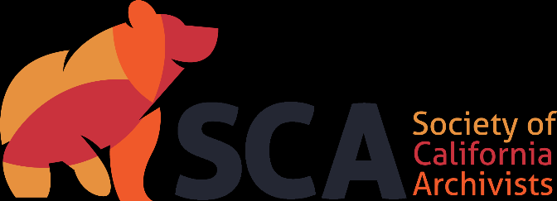

Society of California Archivists
Candidate’s Statement for 2024 Election

Candidate for: Nominating Committee

Years: 2024-2026 (2-year term)

Name: Hilary Swett

Institution: Writers Guild Foundation

Professional Background (begin with current position and areas of responsibility, and briefly summarize duties):

I have been Archivist at the Writers Guild Foundation in LA for almost 10 years, much of my professional career. It’s a very small, private, entertainment non-profit and my responsibilities as the solo archivist are broad. I engage in acquisitions, processing, description, and access for all manuscript collections. I also handle all of the research questions, train and supervise interns and volunteers, manage technical systems, and engage in outreach. Previously, I had a variety of short-term and part-time library and archives jobs in a law firm library, an academic library, a public library and archival work for individual clients.

Educational Background (degrees and other applicable training):
MLIS, San Jose State University, 2012
BA, Film Production, Loyola Marymount University, 2004

Professional Affiliations (list organizations, dates and extent of your involvement, e.g., SCA activities, memberships, committee work):
- Society of California Archivists, member since 2012
- Society of American Archivists, member since 2011
- SAA Lone Arrangers Section steering committee – Vice Chair/Chair Elect, 2023-2024
- Los Angeles Preservation Network (LAPNet) Steering Committee member since 2015
- LA As Subject, Member and Archives Bazaar Exhibitor, since 2015
  - Committee Member, Archives at Risk, 2020-present
  - Committee Member, Archives Bazaar Virtual Exhibit, 2020

Taking into account differing levels of monetary and institutional support, how can the Nominating Committee ensure that candidates are chosen from all facets of the archival profession: lone arrangers, large institutions, government archives, academic archives, corporate archives, library, museum, and other settings?

The nature of archival work means we are often situated in unique environments with unique holdings and subject matter. Despite these differences, our strength lies in our shared goals and passion for what we do and the desire to support each other and grow as professionals. One of the great benefits of SCA membership is the opportunity to learn and share with people outside of our close networks. The Nominating Committee plays a role in fostering new ideas and connections by suggesting an array of people for leadership roles that reflect the diversity of member needs and perspectives.

As a solo archivist who took a winding path to this work with minimal monetary and institutional support, I understand both the challenges and the benefits of service and engagement. I recognize that archivists in any setting and at any point in their careers can offer valuable insights. Candidates put forth for office should run the gamut from established archivists to newer professionals, those in small shops or specialized environments, and people who are un- or underemployed. The members of the Nominating Committee should look inside and outside of their own professional relationships to identify candidates who have unique backgrounds that might be valuable additions to the board and to encourage members with untapped potential to increase their engagement with SCA. Such candidates might be less visible in the profession, not presenting or writing about their work for example, or hesitant about self-nominating and should be recruited directly and eagerly. I look forward to participating in this meaningful work if I am elected to the Nominating Committee.

Please detail your efforts to integrate equity and inclusion practices into your work and any plans you may have for this as a member of the Nominating Committee.

A large part of the work we do at the WGF Library involves decreasing barriers to finding work in the entertainment industry and providing a foot in the door which might not be possible for people otherwise. Many of our patrons represent diverse perspectives in terms of race, ethnicity, gender identity, age, ability, and background, which are missing from the largely white and male power structures of the industry. We reflect often on equity and inclusion, layering it into everyday practice and celebrating when a community member achieves success. Our library and archive are open to all for research and self-education and I prioritize access by: creating a welcoming physical and virtual environment with easily navigated and accessible web pages, finding aids and catalog systems; highlighting the careers and collections of women and less well-known people as often as I can on social media and otherwise; giving all researchers equal respect and assistance; encouraging access to collections no matter the question or stature or (lack of) affiliation; being flexible with interns who are taking that initial step into the profession and mentoring and welcoming them; and cultivating more representative collections.

I will bring this same open attitude to my work as part of the Nominating Committee. I will listen to the spectrum of SCA members and leaders to identify issues that need to be addressed and examine who might be in a position to help. I will encourage early career professionals and those in less represented types of repositories to get involved. I will seek out people who are knowledgeable about current professional trends but also those who might have a potential vision to propose new ideas and solutions. Having a range of perspectives certainly will benefit the health of the organization and archivists working throughout the state.

