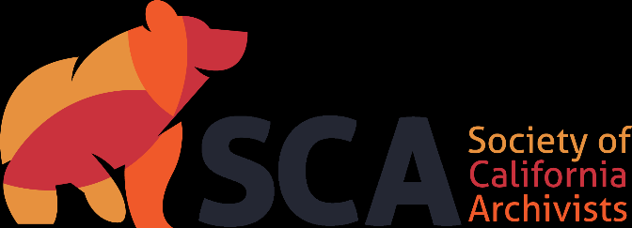

Society of California Archivists
Candidate’s Statement for 2024 Election

Name: Alexandria Post
Institution: San Francisco State University, J. Paul Leonard Library Special Collections & Archives
Candidate for: Treasurer
Years: 2024-2026 (2-year term)
Professional Background (begin with current position and areas of responsibility, and briefly summarize experience):
I am the Special Collections Research Assistance, Outreach, and Instruction Team Lead. I oversee and coordinate our reference services, instruction, and outreach initiatives.
Prior experience: Special Collections Reference and Instruction Librarian (2019-2021) at SFSU; Processing Archivist (2017-2018) at SFSU; Archives and Manuscripts Librarian at Mills College (2015-2017).
Experience prior to the completion of my degree: Staff position in the History Room at SFPL (2014-2016); Archives Assistant in the Labor Archives and Research Center at SFSU (2014-2016).

Educational Background (degrees and other applicable training):
- MLIS, emphasis in Archives and Records Management, San Jose State University
- BA in Comparative and World Literature, San Francisco State University

Professional Affiliations (list organizations, dates and extent of your involvement, e.g., SCA activities, memberships, committee work):
Society of California Archivists
- Treasurer (two-year term, 2022-2024)
- Local Arrangements Co-chair (three-year term, 2020-2023)
- Election Committee, member (2019-2022)
- Local Arrangements Co-chair (2017-2018)
- Local Arrangements Committee, member (2015-2016)
American Printing History Association, NorCal Chapter
- President (2022—)
- Secretary (2021-2022)
- Vice President of Programs (2016-2021)
Society of American Archivists, member (2014--)
American Printing History Association, member (2015--)

What skills do you possess that are particularly applicable to the position?
I am delighted to run again for SCA Treasurer. I am detail-oriented, accountable, and enjoy troubleshooting and finding creative solutions to unique problems. I have been SCA Treasurer since 2022 and have learned a great deal about the nuts and bolts of SCA as an organization and have enjoyed working with the Board. Additionally, as a former Local Arrangements Co-chair for several annual meetings, I have experience managing the LAC budget and working closely with the SCA treasurer to ensure the LAC budget and SCA budget match. Prior to entering the library and archival profession, I managed budgets for arts small organizations and created budgets for project and operating grant proposals. I believe my previous experience will help shape SCA’s budget and ensure the organization’s financial health.

Please detail your efforts to integrate equity and inclusion practices into your work and any plans you may have for this as Treasurer.
My efforts to integrate equity and inclusion in my profession includes participating in SFSU’s Special Collections DEI Committee, working with my colleagues to provide background and historical context to our collections, remediate harmful language in our archival finding aids, and support our users by improving access to our digital collections. I am also looking at our current primary source instruction and thinking of ways to help students interact with a somewhat unmediated history and prepare them for the unexpected or shocking materials they might encounter.
As treasurer, I hope to also address equity issues in the profession. Early in my career, one of the major barriers to participating in professional organizations has been a lack of resources. An immediate concern for me is addressing member’s needs, particularly when it comes to the affordability of membership and/or participation in SCA programs. Finally, I will advocate for a more diverse representation on the Board.

